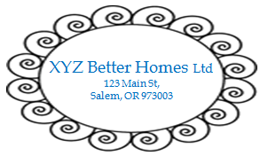

CERTIFICATE OF MATERIAL

Date: mm/dd/yyyy

To: The Kroger Co. Invoice Reference: 123456
1014 Vine Street Import Po Reference: 500-10101
Cincinnati, Ohio 45202

P.O. STYLE # PCS CTNS MEASUREMENTS (L x W x H)
500-10101 AB123 1 1 W 18 ½” x D 15 3/8” x H 30 ¾”

COMPONENTS OF MATERIALS USD/PC BREAKDOWN BY NET WEIGHT
& PROCESS (IN KG & %)
STYLE #
Steel Tube & Wire USD$$ 1.93 .76 45
PE Cover USD$$ 0.87 .19 33
Plastic Connector USD$$ 0.24 .14 20.5
Spare Parts USD$$ 1.26 .21 1.5
TOTAL USD$$ 4.30 1.30 100

_________________________
Authorized Signature

